**DMX new SSO implementation:**

If your session has expired and you are trying to acess below URL:

[https://newdmxdev.tapestry.com/ssologin](https://newdmxqa.tapestry.com/ssologin)

As per new SSO implementation, It will redirect you to microsoft login page where you need to enter you network credentials.

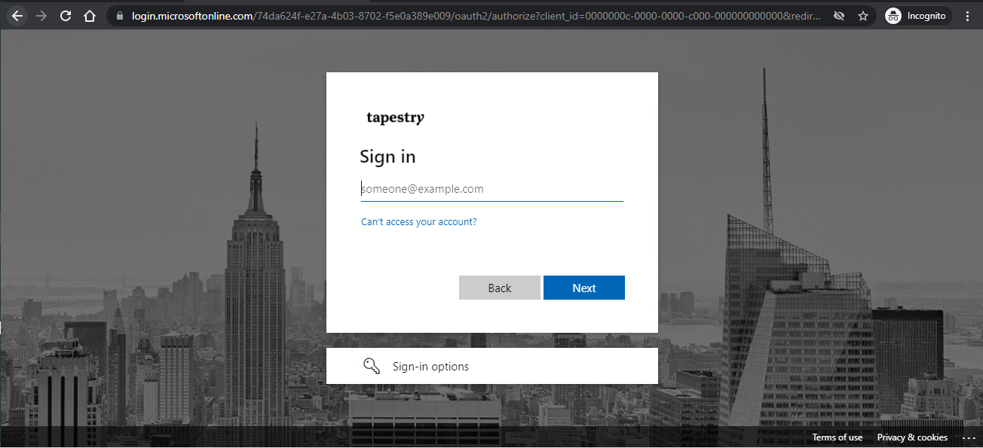

If your session is alive then it will redirect you to dashboard page:

